**EXPORT INVOICES**

**Wharfage Estimation Invoice Steps**

1. **Create** **Export** **Application** under **Export** **Application**.

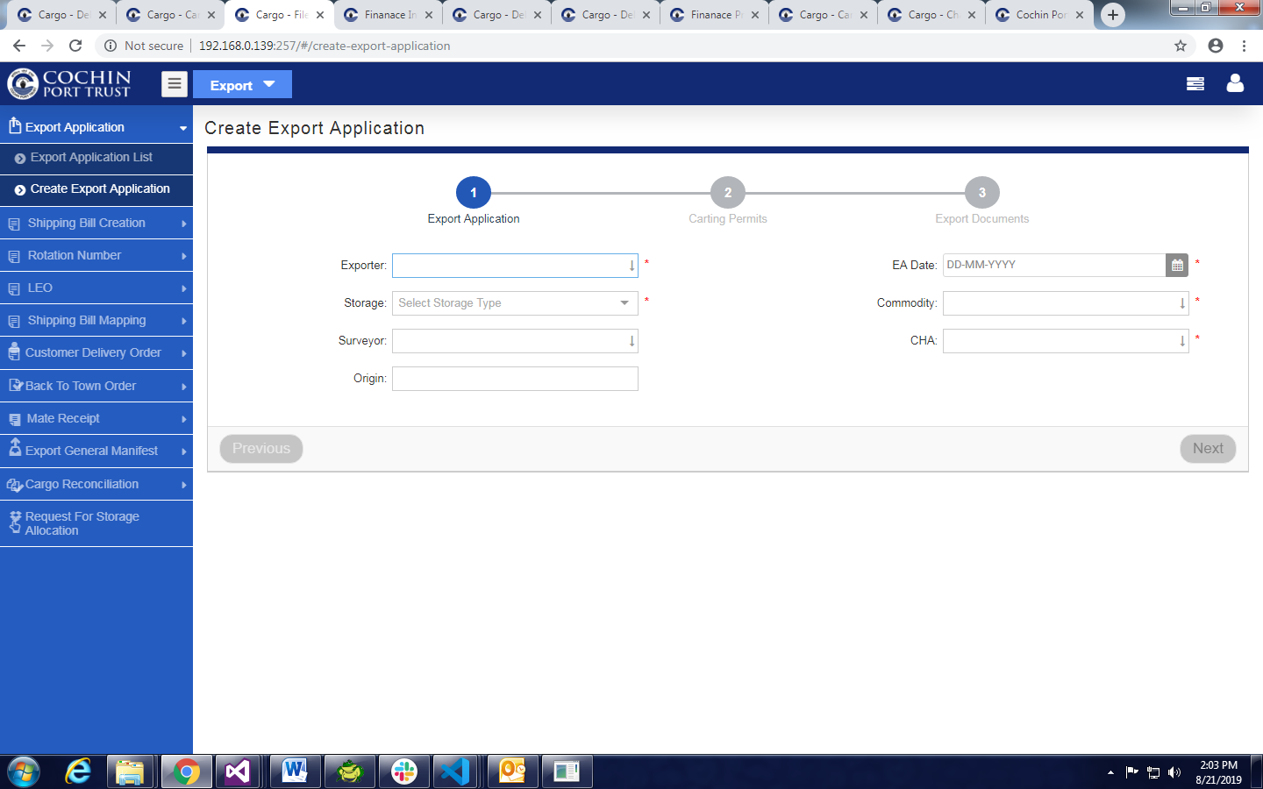

* Fill all mandatory Fields.
* Click on **Next** Button

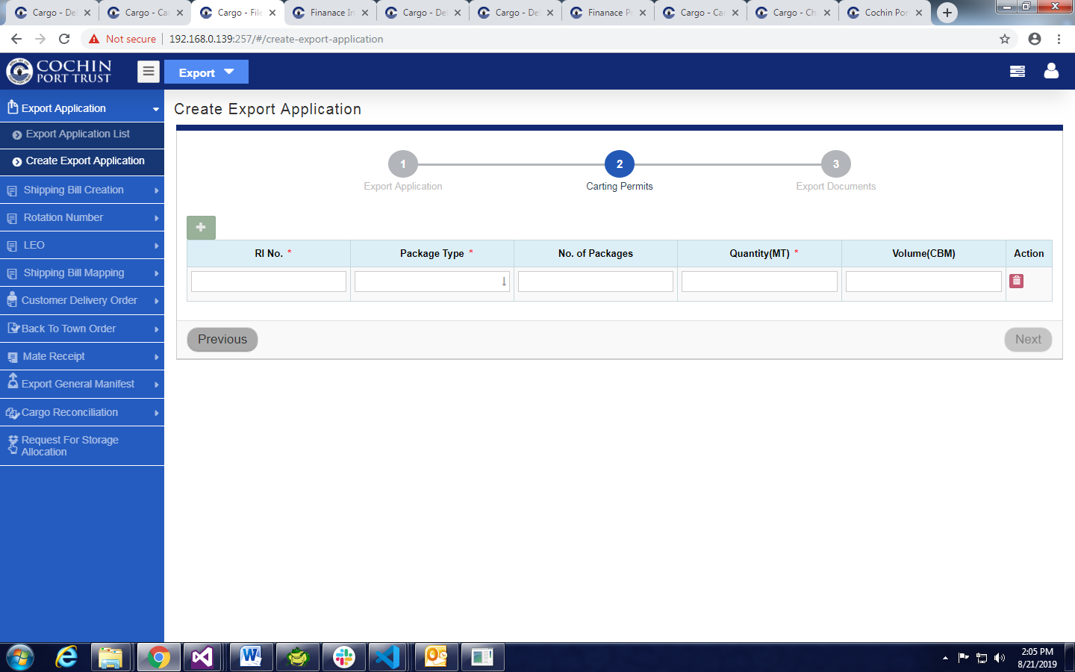

* Fill All Mandatory Fields in Carting permits Tab.
* Click on Next and Click Save & Exit button.

1. Click **on Shipping Bill Entry** under **Shipping Bill Creation**.

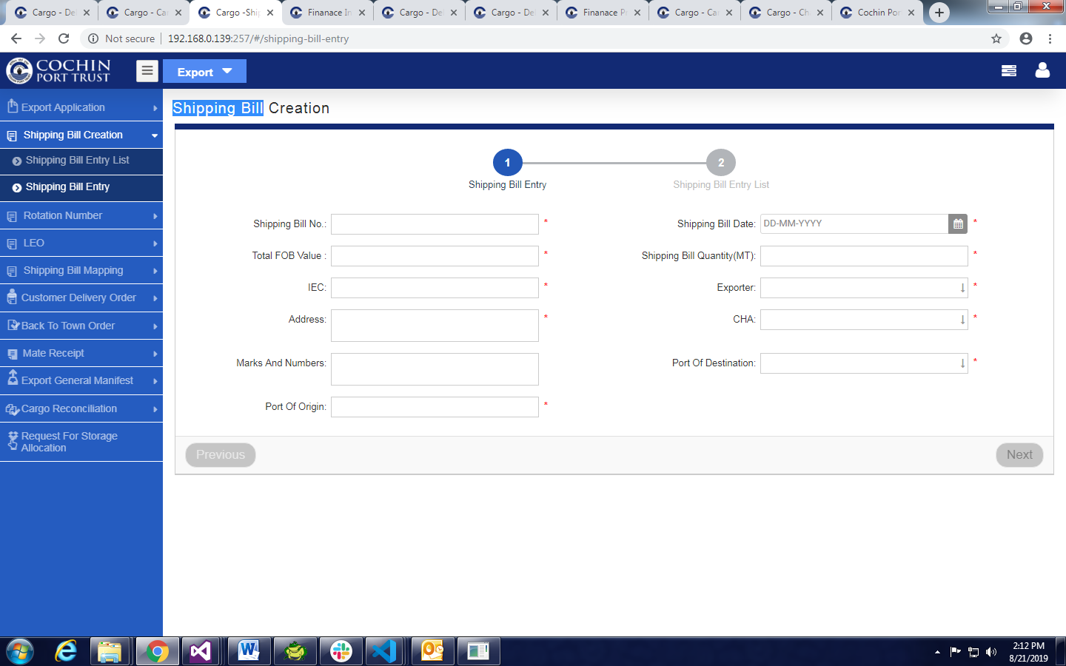

* Fill All Mandatory Fields in **Shipping Bill Entry** Tab.
* Click on **Next** Button.
* Fill All Mandatory Fields in **Shipping Bill Entry List** Tab.
* Click on next Button and Click on **Save & Exit** Button

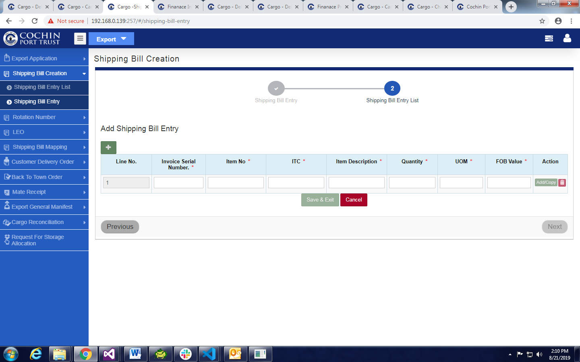

1. Click On **Rotation No Entry** under **Rotation Number**.

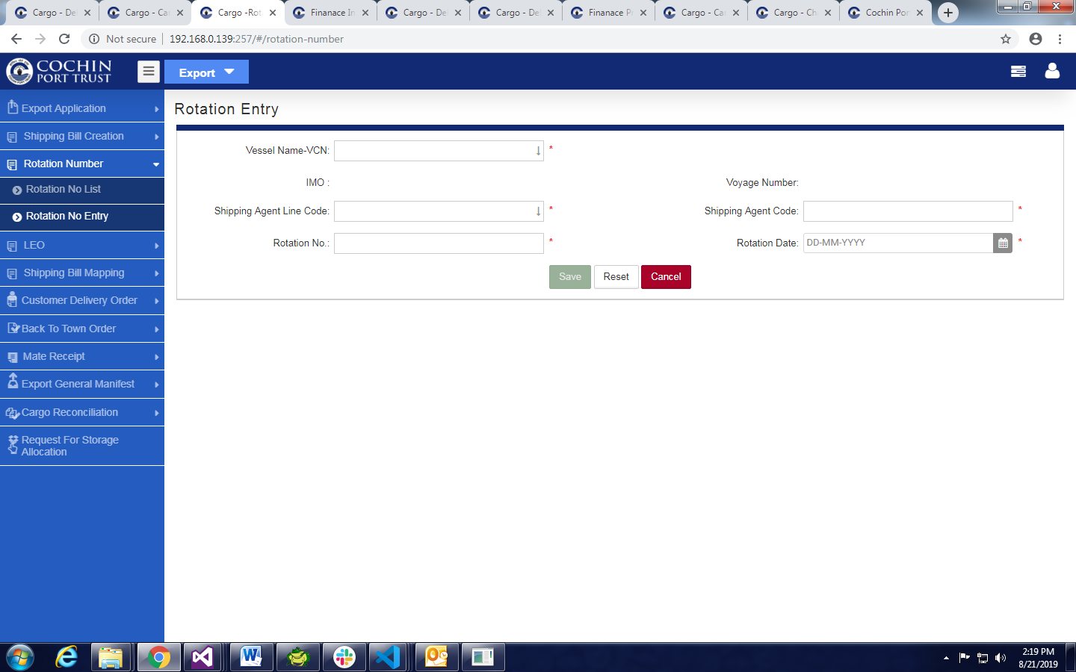

* Fill All mandatory Fields.
* Click on **Save** Button.

1. Click on **LEO Entry** under **LEO**

* Fill All mandatory Fields.
* Click on **Save** Button.

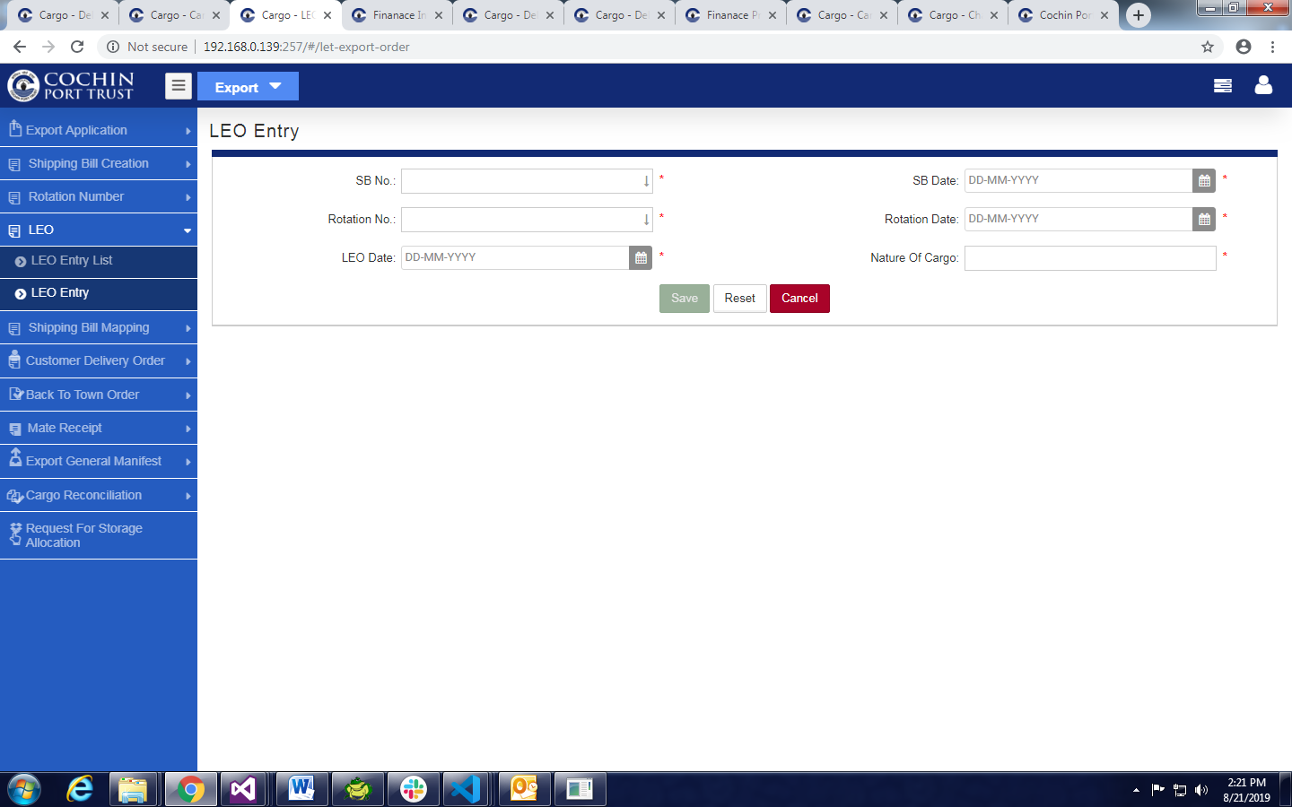

1. Click on **Shipping Bill Mapping** Under **Shipping Bill Mapping.**

* Fill All Mandatory Data .
* Click on **Next** Click on **Save & Exit** Button

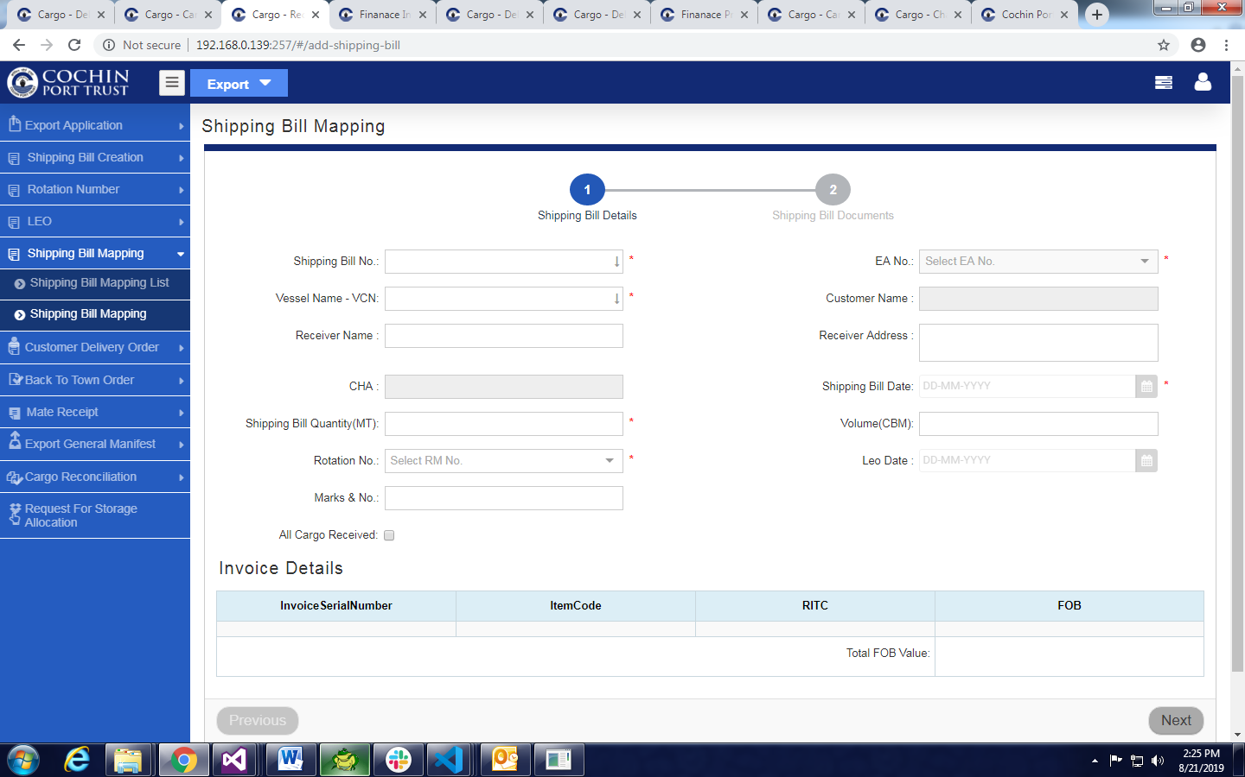

1. To view and Generate Wharfage Estimation Invoice

* Click On **Shipping Bill Mapping List**
* Click on Estimation Invoice Icon.
* Click on Generate Invoice Button.

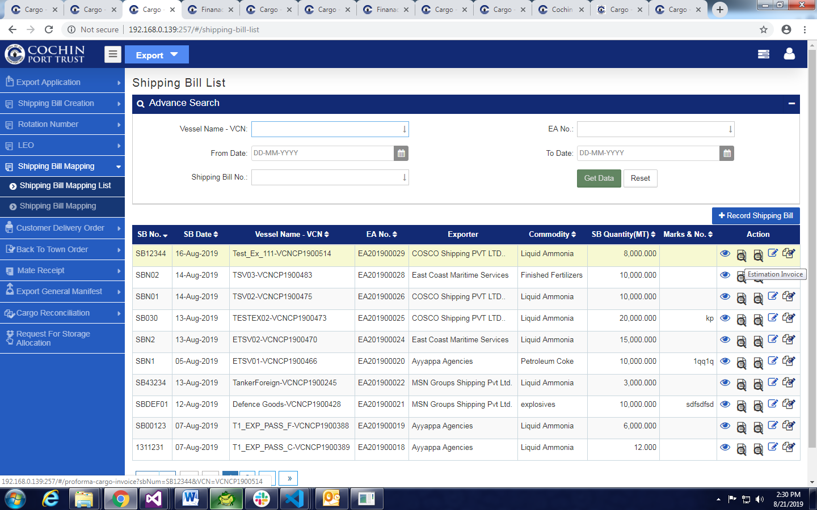

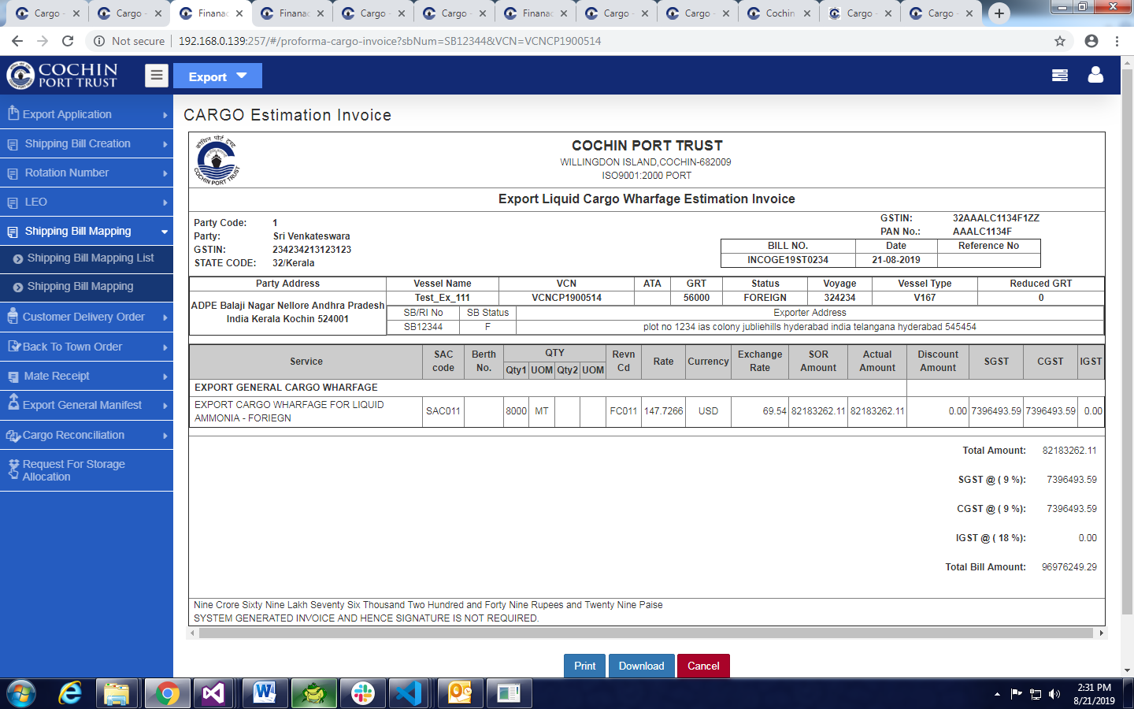

**Wharfage Invoice (Final Invoice)**

1. Open Jetty Operations Module
2. Click on Vessel Cargo Operations

* Select **Export** Radio Button
* Select VCN Number From Auto fill Suggestion.

1. Click on Record Surveyor in Appoint surveyor.

* Give mandatory Information.

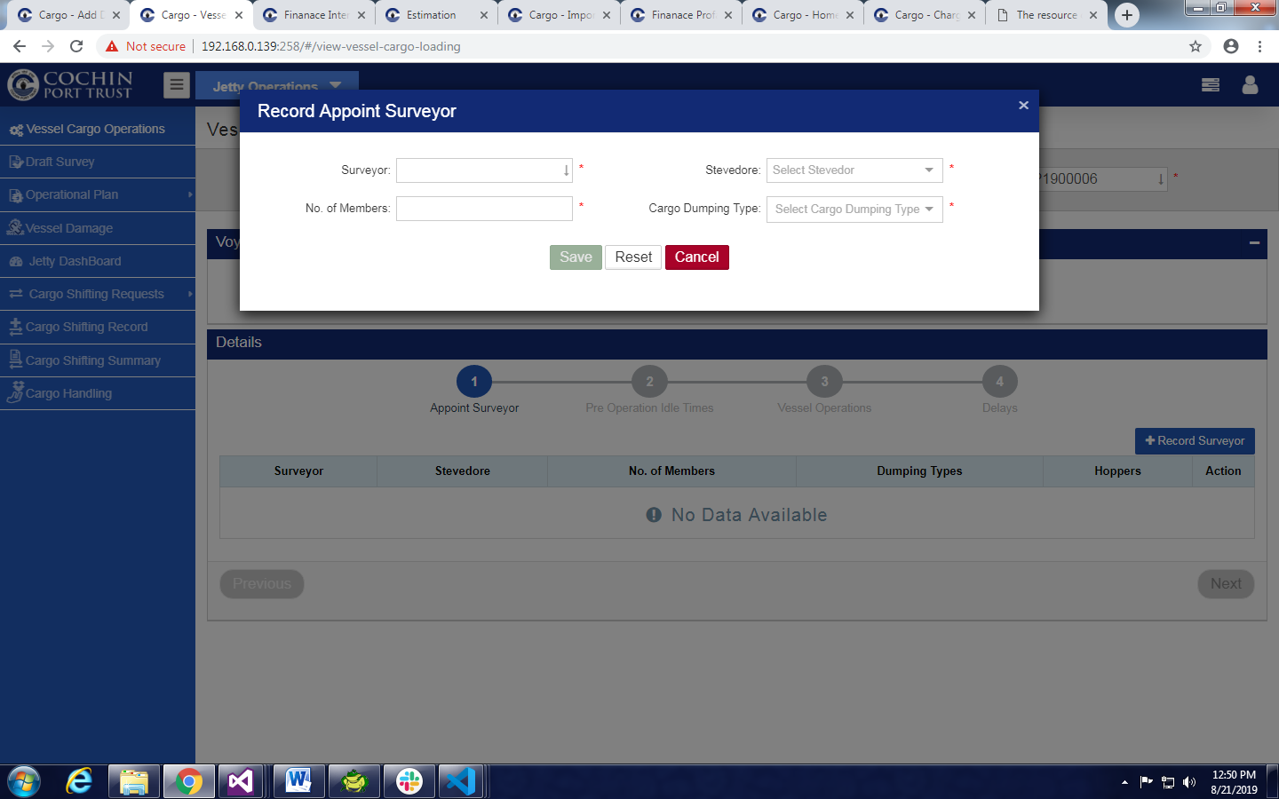

* Click on save

1. Click on Pre Operation Idle Times.

* Click on Pre Operation Idle Times Button.

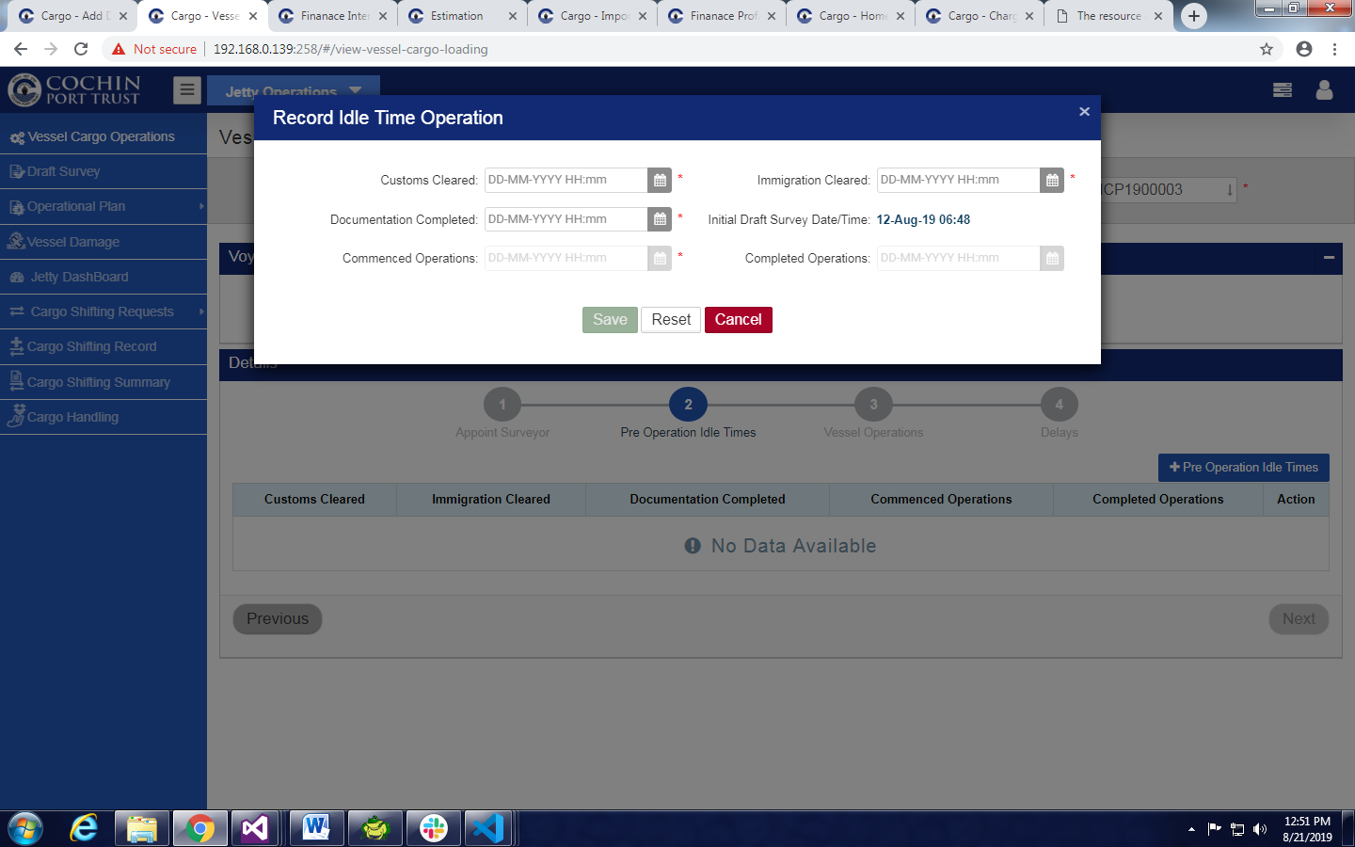

* Give All mandatory Data click on save button

1. Click on Vessel Operations tab

* Now Click on Record Vessel Cargo Operations.
* Provide all mandatory Data

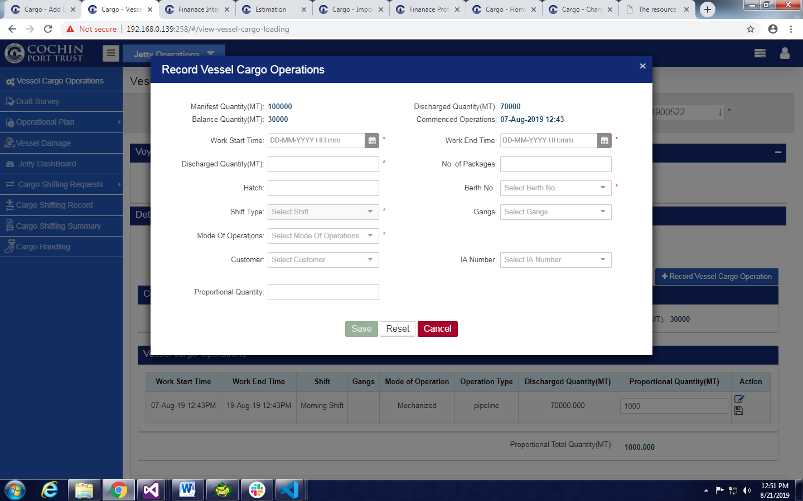

* Click on Save Button .

1. Click on Delays Tab

* Click on Record Delay button .
* Provide all mandatory Data

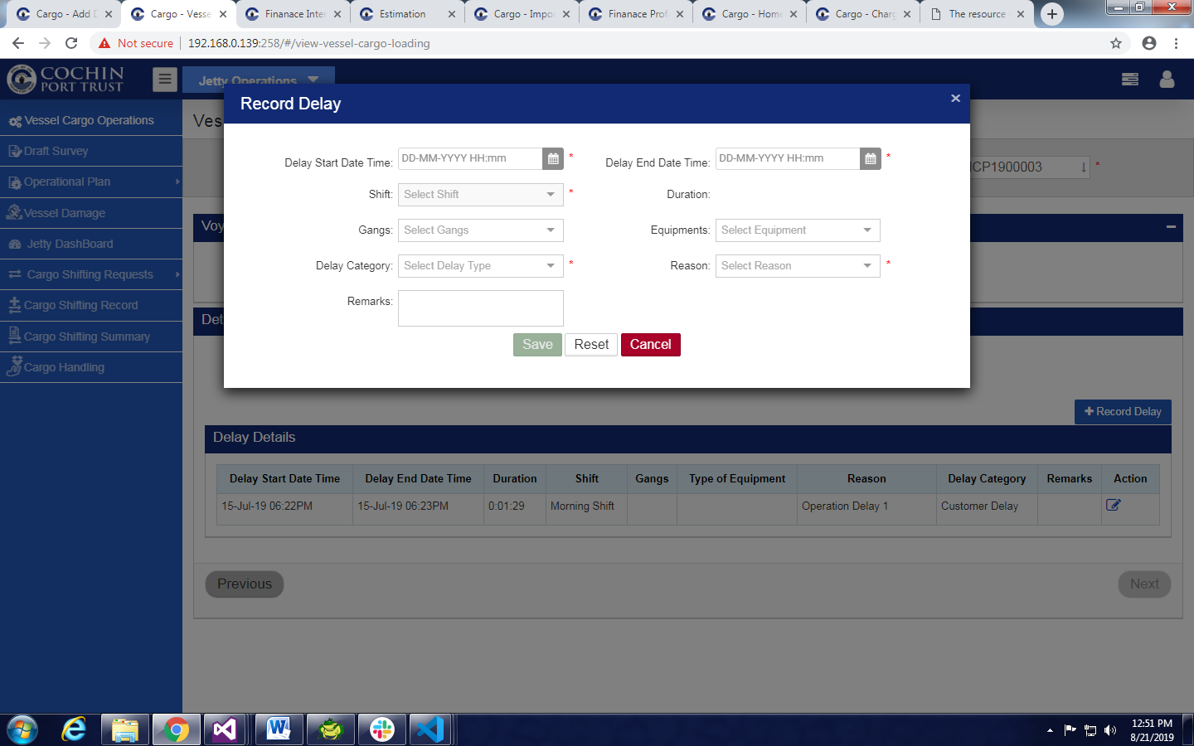

* Click on Save Button .

1. Click on Pre Operation Idle Times.

* Click on Edit Icon in Actions
* Completed Operations Date Time Picker Will enabled
* Select valid Date

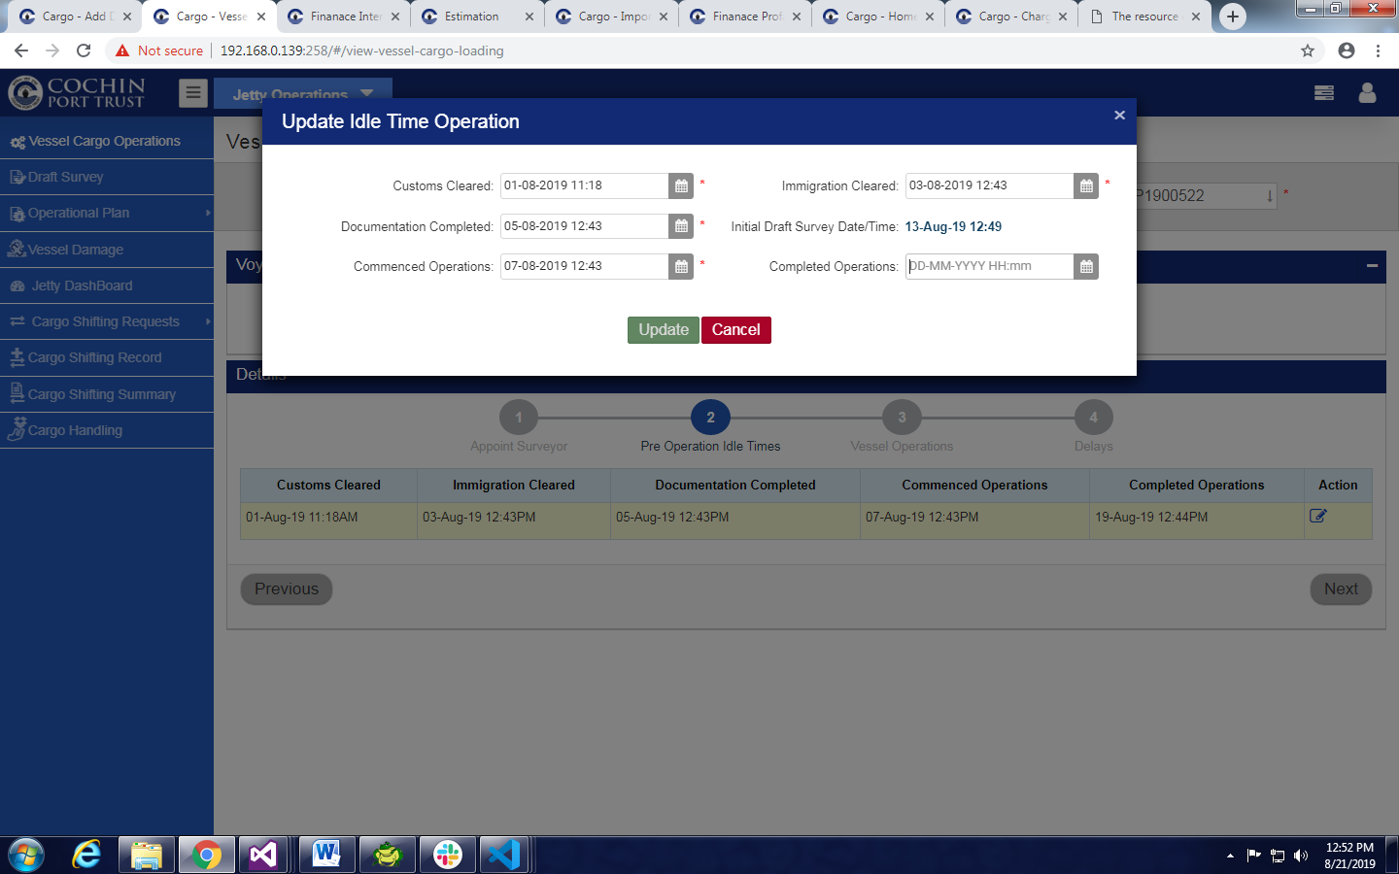

* Click on Update button

1. Click on Draft Survey

* Select VCN Number From Auto fill Suggestion.
* Click on Record Draft Survey button.
* Give Valid Data and Click on Next .

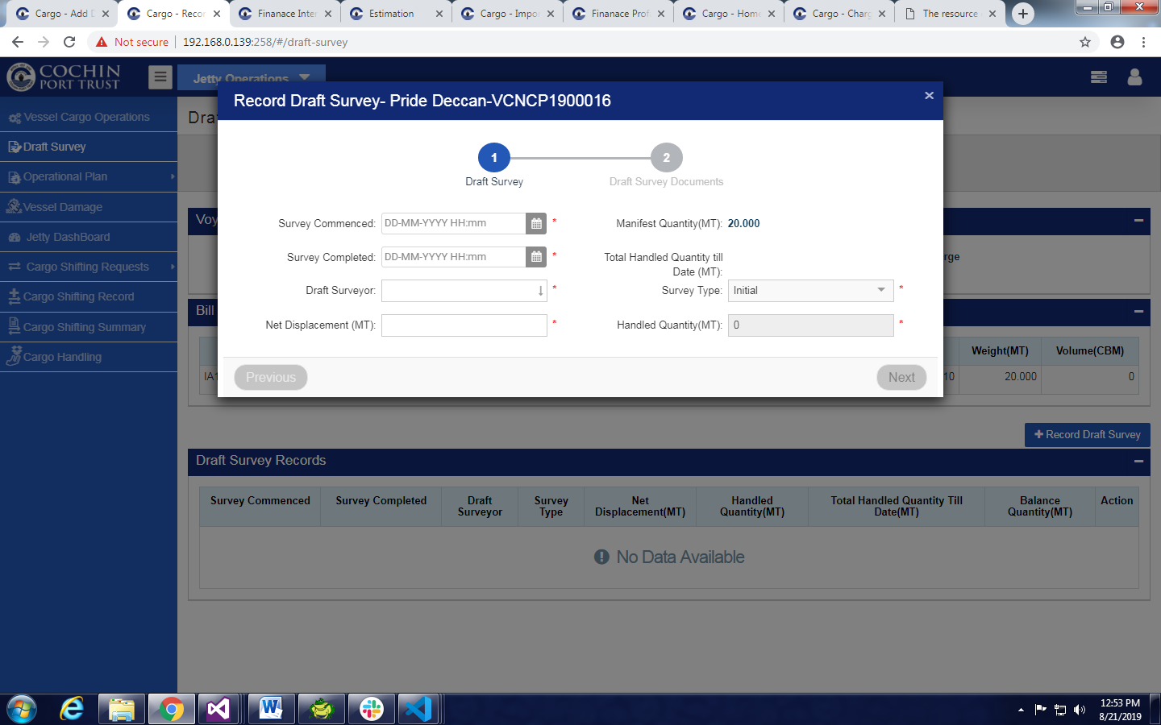

* Click on Save& Exit Button.
* Click on Record Draft Survey button.
* Give Valid Data
* Select Survey Type As Final
* Click on Next
* Click on Save& Exit Button.

1. To view (Final) Invoice Open Finance Module.

* Click on Invoice .
* Invoice List Will Display.
* Filter with VCN Number or Application Dropdown menu and Application Module.
* Click On View Final Invoice Will Display.

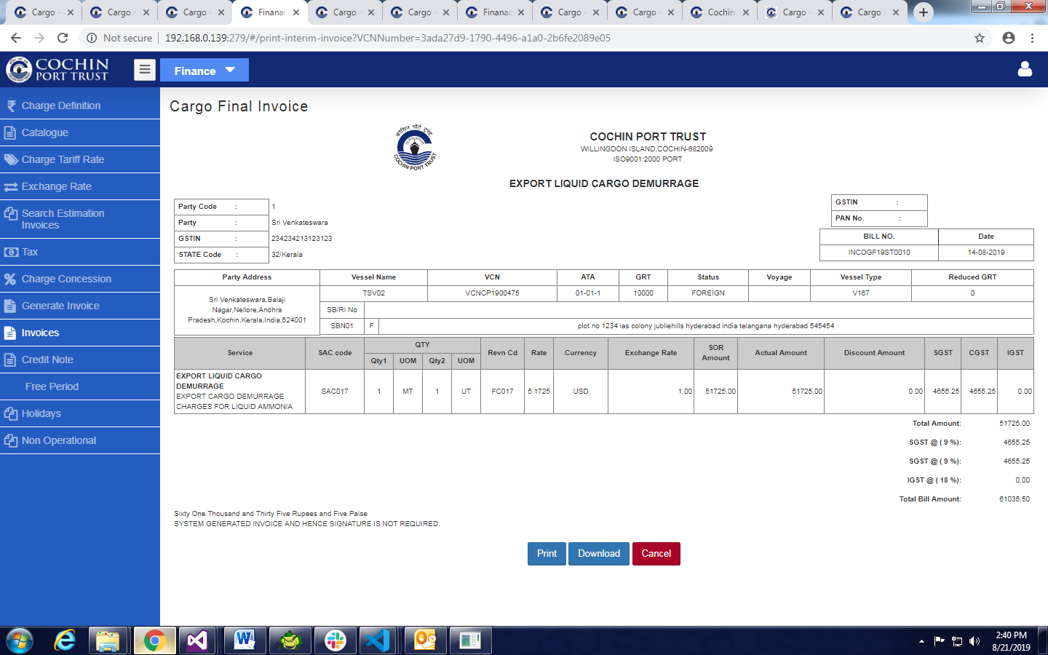

**Demurrage Invoice Steps**

1. **Create** **Export** **Application** under **Export** **Application**.



* Fill all mandatory Fields.
* Click on **Next** Button



* Fill All Mandatory Fields in Carting permits Tab.
* Click on Next and Click Save & Exit button.

1. Click **on Shipping Bill Entry** under **Shipping Bill Creation**.



* Fill All Mandatory Fields in **Shipping Bill Entry** Tab.
* Click on **Next** Button.
* Fill All Mandatory Fields in **Shipping Bill Entry List** Tab.
* Click on next Button and Click on **Save & Exit** Button



1. Click On **Rotation No Entry** under **Rotation Number**.



* Fill All mandatory Fields.
* Click on **Save** Button.

1. Click on **LEO Entry** under **LEO**

* Fill All mandatory Fields.
* Click on **Save** Button.



1. Click On Request For Storage Allocation

* Select VCN Number From Auto fill Suggestion
* Select IA Number from Drop down menu.
* Click On Record Request For Storage Location
* Give Valid mandatory Data
* Click on Save

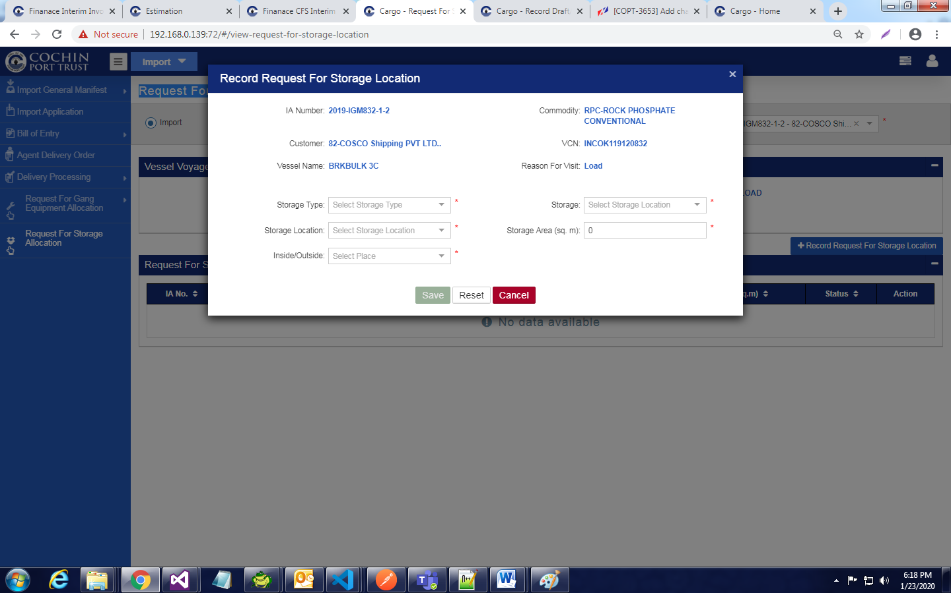

1. GO To YARD Operations Module

* Find **Notifications And Give Approve**

1. **Go to Export Module**

* Click On Export Application
* Click on Allocate Storage Icon
* Provide Mandatoty Data
* Click On Save

1. Go to YARD Operations

* Click On **Record Shore to Storage Movement**
* **Provide Valid Data**
* **Click On Save**

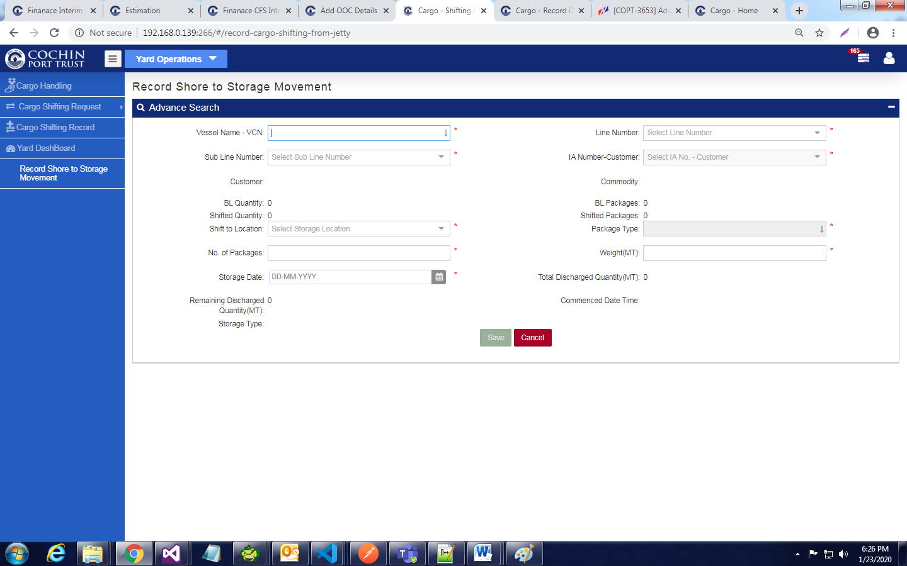

1. Open **Yard Operations** Or **Warehouse Operations** Module
2. Click On Cargo Handling

* Select Export Radio Button
* Fill Customer Name from Auto Suggestion box
* Select Export Application Number
* Fill Valid Data Click on Save

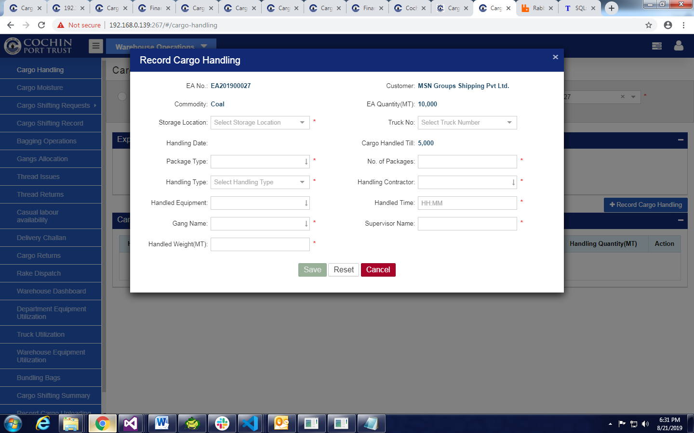

1. Click on **Shipping Bill Mapping** Under **Shipping Bill Mapping.**

* Fill All Mandatory Data .
* Click on **Next** Click on **Save & Exit** Button



1. To view and Generate Demurrage Invoice

* Click On **Shipping Bill Mapping List**
* Click on Demurrage Invoice Icon.
* Click on Generate Invoice Button.

